

Name: Saim Nsiar
Class: ADCS 2A
Roll No: 2500626
Subject: Web Technology

Lab Task 1
Code:
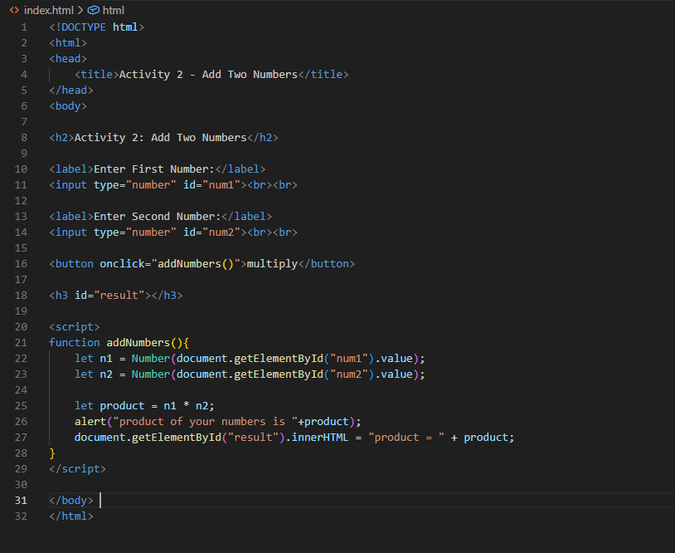

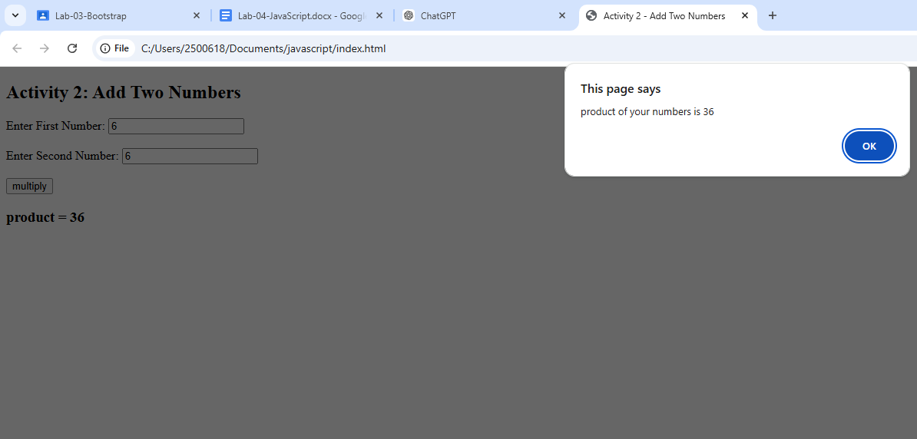
Lab Task 2
Code:
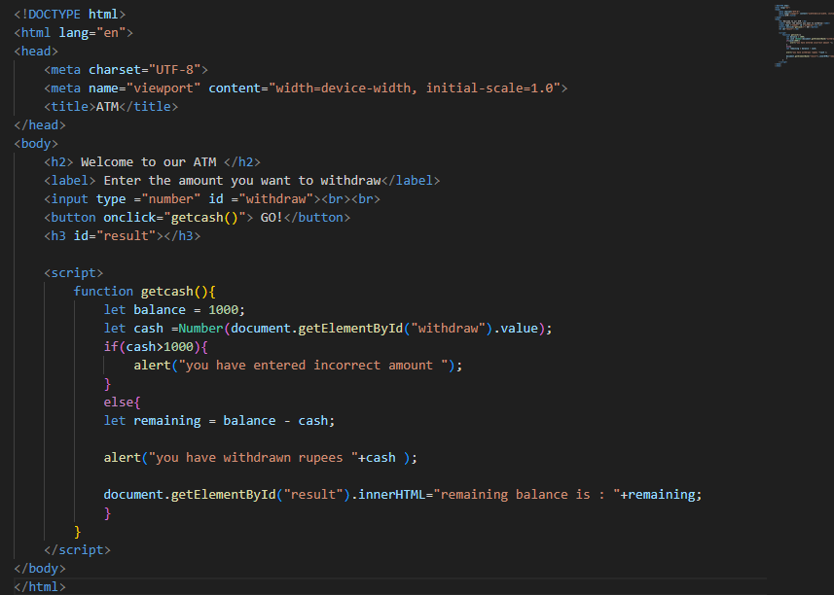

Output:

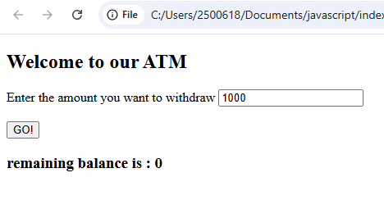
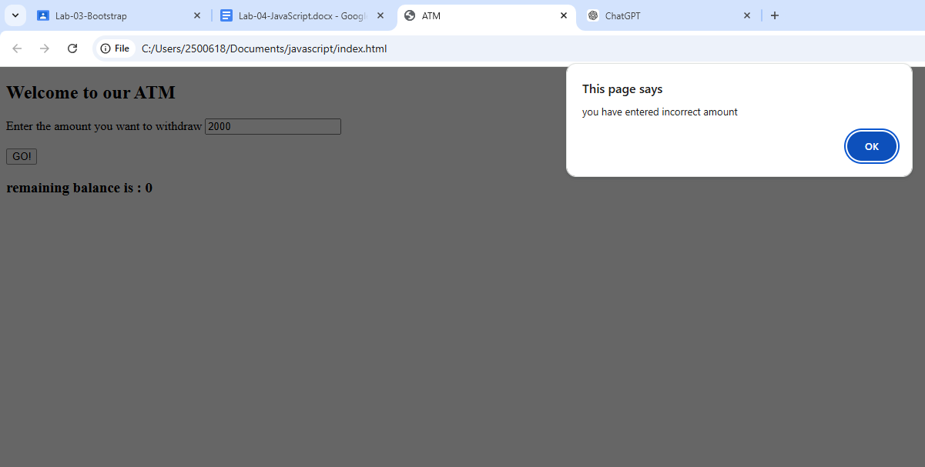

Lab Task 3
Code:

<!DOCTYPE html>
<html lang="en">
<head>
<meta charset="UTF-8">
<meta name="viewport" content="width=device-width, initial-scale=1.0">
<title>Print Numbers</title>
</head>
<body>
<h1>Print number from 1 to 20</h1>

<h3 id="result"></h3>

<script>
let output = "";

for (let i = 1; i <= 20; i++) {
output += i + " ";
}

document.getElementById("result").innerHTML = output;
</script>

</body>
</html>

<!DOCTYPE html>
<html lang="en">
<head>
<meta charset="UTF-8">
<meta name="viewport" content="width=device-width, initial-scale=1.0">
<title>Print Numbers</title>
</head>
<body>
<h1>Print number from 1 to 20</h1>

<h3 id="result"></h3>

<script>
let output = "";

for (let i = 1; i <= 20; i++) {

if(i%2==0)
output += i + " ";
}

document.getElementById("result").innerHTML = output;
</script>

</body>
</html>

<!DOCTYPE html>
<html lang="en">
<head>
<meta charset="UTF-8">
<meta name="viewport" content="width=device-width, initial-scale=1.0">
<title>Print Numbers</title>
</head>
<body>
<h1>Print number from 1 to 20</h1>

<h3 id="result"></h3>

<script>
let output = "";

for (let i = 10; i >= 1; i--) {

output += i + " ";
}

document.getElementById("result").innerHTML = output;
</script>

</body>
</html>

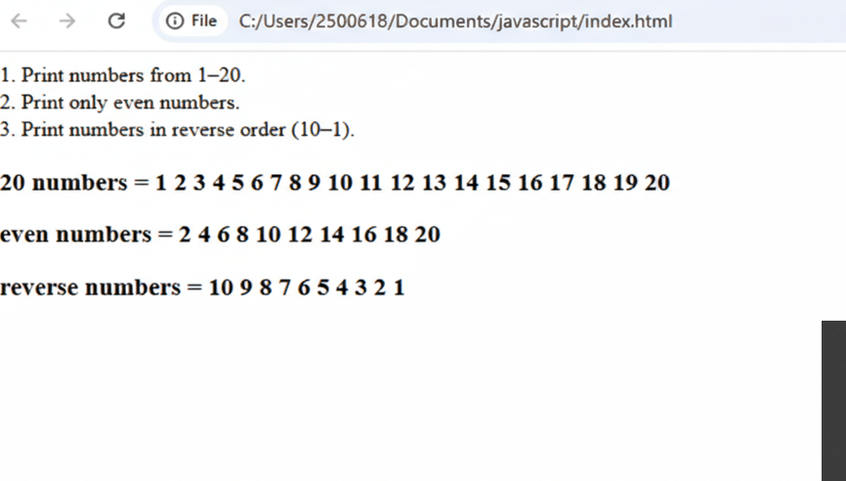
Lab Task 4
Code:
